

**General Essential Mathematics 2019**

**Name:**

**INVESTIGATION : Building Ramps**

**(Take Home Part)**

**Due Date:**

**Weighting: 9% of the year**

***This investigation comprises both a take home section and an in-class validation section. Although the take home section will not contribute to the mark for this assessment, the in-class validation test will assess your understanding from the take home section. It is expected that you complete the ENTIRE take home section. You will be allowed to use your take home section as notes during your in-class validation.***

The diagrams in the following pages are NOT drawn to scale

You and you’re friends have been riding BMX bikes for some time and have decided to start building ramps for a bit of added excitement.

Before starting the build, many prototypes will be drawn up to determine which is the most ideal for what you and your friends need.

**Part 1:**

The most basic form of ramp is the one shown below.

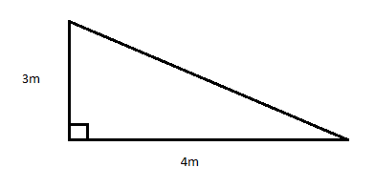

a) Calculate the length of the top piece of wood

b) If the height was changed to 2m, what would the new length of the top piece be?

c) If the height and length of the ramp was halved (from the original diagram), What would the new length of the top piece be? Show working

d) If the height and length of the ramp was doubled (from the original diagram), What would the new length of the top piece be? Show working

e) If the height and length of the ramp are increased by half their original size, what will be the new length of the top piece? Give reasons without calculating

f) Complete the following table to show your previous answers and some new ones:

|  |  |  |  |
| --- | --- | --- | --- |
| **Height** | **Length** | **Top** | **Total** |
| 3m | 4m |  |  |
| 1.5m | 2m |  |  |
| 6m | 8m |  |  |
| 4.5m | 6m |  |  |
| 9m |  |  |  |
|  |  | 25m |  |
|  |  |  | 120m |

g) Describe your findings:

**Part 2:**

After some discussions, it has been decided that a curved ramp is far better for BMX riding. A prototype is shown below. To curve the top length, the piece of wood must be 2m longer than the direct hypotenuse.

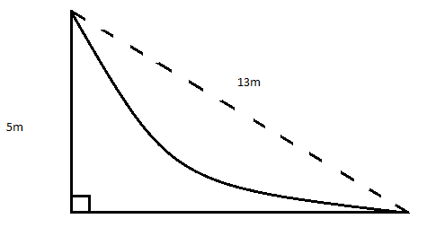

a) What is the total length of wood required to make this ramp?

b) If the height and length of the ramp was halved (from the original diagram), what would the new total length of wood be? Show working

c) If the ramp keeps the dimensions shown in the diagram, and each piece of wood is made 1.5m wide, what would be the total area of wood needed?

*Only the base, height and top piece are required (do not include side pieces)*

d) Which of the following is the best amount of wood to buy to build the ramp?

Option 1: 46m²

Option 2: 42m²

Option 3: 52m²

**Part 3:**

After consultation with your friends, you have decided that you need a down ramp as well. Consider the following diagrams. *Remember, to create the slope you will need 2 extra metres of wood.*

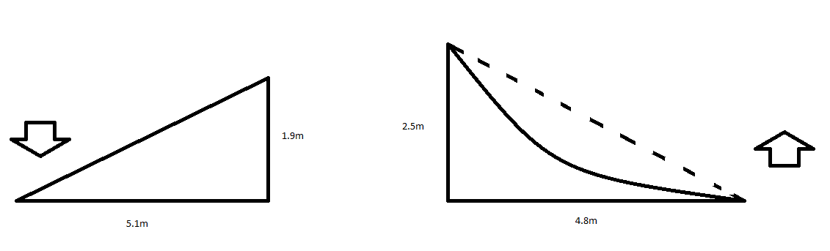

a) What is the total length of wood required for the six pieces?

b) If each length and height was doubled, what would be the new total length?

c) If each length and height was increased by half, what would be the new total length?

d) Compare your answers to part one and comment on similarities and differences:

**Year 12 Essential Mathematics**

**Investigation 2 – Building Ramps Time allowed: 60 minutes**

**Weighting 9%**

**Validation Test**

Part 1:

1. Consider the following ramp:

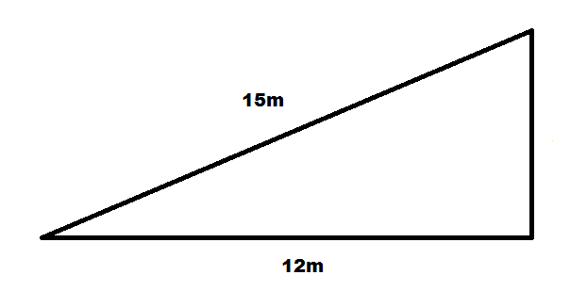

a) What is the height of the ramp?

(3 marks)

b) If the two known pieces became 7.5m and 6m, what would the new height be?

(2 marks)

c) If the two known pieces became 22.5m and 18m, what would the new height be?

(2 marks)

d) If the height became 18m, what would the two other lengths become?

(4 marks)

2. Consider the following ramps:

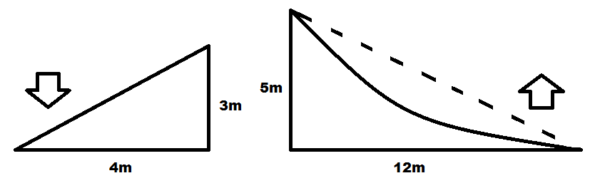

a) What is the total length of the down ramp?

(2 marks)

b) What is the total length of the up ramp?

(the top piece has to be extended by two metres to make the curve)

(2 marks)

c) What would be the total length of the ramp if both heights and lengths were halved?

(4 marks)

d) If all pieces of wood have to be 0.5m wide, what is the total area of wood that is required?

(Use your answers from part a & b)

(2 marks)

e) Which of the following is the best amount of wood to buy to build these ramps?

i) 26m²

ii) 24m²

iii) 21m²

(1 mark)

**Part 2**

**3. Answer the following multiple choice questions**

### The three sides of a right-angled triangle measure 40 m, 41 m and 9 m. The length of the hypotenuse is:

### (i) 9 m (ii) 40 m (ii) 41 m (iv) none of these

1. A map has a scale of 1 : 5000. 5cm on the map is equal to how far in real life?

### (i) 5000 cm (ii) 2500 cm (iii) 25 m (iv) 250 m

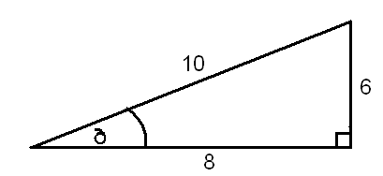c) In relation to the angle, which is the opposite side?

### (i) 10 (ii) 8 (iii) 6 (iv) none of these

1. The value for *x* in the diagram is given by:

12__

sin 30O

12__

tan 30O

### (i) 12 x sin 30O (ii) 12 x cos 30O (iii) (iv)

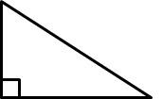

x

12

30˚

**Question 4 (5 marks – 3,2)**

|  |
| --- |
| 1. A boy notices a bird sitting at the very top of a 10m tall tree. If he is standing 8m from the base of the tree, what is the distance between his eye and the top of the tree? |
| 1. What is the angle of elevation from the boy’s eye to the top of the tree? |

**Question 5 (3 marks)**

The school council needs to have a ramp build over the steps of each of the building exits, to accommodate a student in a wheelchair. If the school building is 35cm off the ground and the ramp length is 61cm, how far should the steps reach out to accommodate the ramp?

**Question 6 (3 marks)**

A ladder 12 m long leans against a wall. If it forms an angle of 400 with the ground, how far is the bottom of the ladder away from the wall?

